**Experiment no-8(a)**

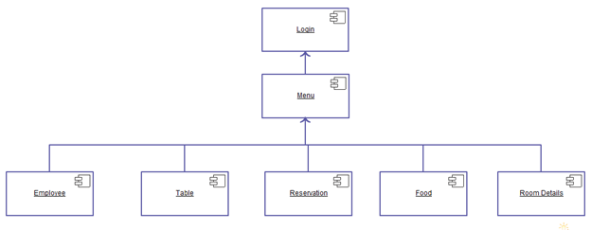

**Fig:-Component diagram for hotel management system(HMS)**